

Internet of things lab ASSIGNMENT

Course code: CSE-402

Submitted to:

Ayanava Paul

Lecturer, UITS



Submitted By:

Md. Shakibul Islam Ramim

ID: 2125051063

Batch: CSE-50

Section: 7B1

Email: 2125051063@uits.edu.bd

## **Analog Input- Digital Output**

### Title: Analog Input (Potentiometer)- Digital Output (LED blink)

### Necessary Equipment:

1. Arduino UNO R3
2. Breadboard
3. 330 Ohm resistor
4. 3 LED
5. Potentiometer
6. Multimeter
7. LED 16*2

### Circuit Figure:

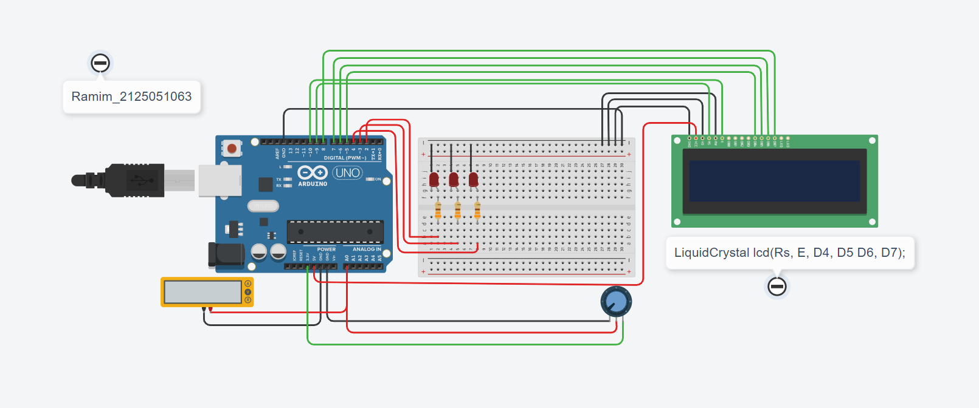

### Code:

#include <LiquidCrystal.h>

// C++ code

int pin[] = {2,3,4};

LiquidCrystal lcd(9,10,5,6,7,8); // Rs, E, D4, D5 D6, D7

void setup()

{

pinMode(pin[0], OUTPUT);

pinMode(pin[1], OUTPUT);

pinMode(pin[2], OUTPUT);

pinMode(A0, INPUT);

lcd.begin(16,2);

Serial.begin(9600);

delay(1000);

}

void loop()

{

lcd.setCursor(6,0);

lcd.print("Ramim:");

float analogval=analogRead(A0);

float volt = ((5*analogval)/1023);

Serial.println(volt);

delay(1000);

if (volt == 00 || volt >= 3.29){

lcd.setCursor(0,1);

lcd.print("L_ON: 1,2,3");

digitalWrite(pin[0], HIGH);

digitalWrite(pin[1], HIGH);

digitalWrite(pin[2], HIGH);

delay(1000);

lcd.setCursor(0,1);

lcd.print(" ");

digitalWrite(pin[0], LOW);

digitalWrite(pin[1], LOW);

digitalWrite(pin[2], LOW);

lcd.setCursor(0,1);

lcd.print("L_OFF: 1,2,3");

}else{

if (volt >= 3.0){

digitalWrite(pin[0], HIGH);

digitalWrite(pin[1], LOW);

digitalWrite(pin[2], LOW);

lcd.setCursor(0,1);

lcd.print("L_ON:1 L_OFF:2,3");

}

else if(volt >= 2 && volt < 3.0){

digitalWrite(pin[0], LOW);

digitalWrite(pin[1], HIGH);

digitalWrite(pin[2], LOW);

lcd.setCursor(0,1);

lcd.print("L_ON:2 L_OFF:1,3");

}

else{

digitalWrite(pin[0], LOW);

digitalWrite(pin[1], LOW);

digitalWrite(pin[2], HIGH);

lcd.setCursor(0,1);

lcd.print("L_ON:3 L_OFF:1,2");

}

}

}

The End